Inventory Module

Main Database
Area
Department
Inventory Master
Supplier/Customer
Item

Opening

Rate
Customer
Customer
Charging Area

Cost Center

Main Transactions
Purchase
Order

Receipt

Issue
Departmental
Transfer
Receipt Return

Issue Return

Purchase
Voucher

Table of Contents

Requirements Analysis
Systems Characteristics
Relationship to other Modules
User Pre-Requisites
Getting Started
Setups
- Area File ...................................................................................................... …………….
- Charging Area File …………………………………………………………………………………………………….
- Department File …………………………………………………………………………………………………………
- Cost Center File ………………………………………………………………… …………………………………….
- Item Category File …………………………………………………………………………………………………….
- Inventory Master File ………………………………………………………………………………………………..
- Item File ……………………………………………………………………………………. ………………………….
- Snaps & Drawings File ……………………………………………………………………. ………………………..
- Opening Balance File ……………………………………………………………………. ………………………….
- Supplier File ……………………………………………………………………. ………………………………………
- Customer File ……………………………………………………………………………………………………………
- Customer Client File …………………………………………………………………………………………………..
- Customer Excise Duty File ………………………………………………………………………………………….
- Sales Tax Rate File…………………………………………………………………………………………………….
- Document Serial File ………………………………………………………………………………………………….
Transactions
- Purchase Order: Ordering Suppliers for Purchase of Items …………………………………………….
- Receipt: Recording Items’ Receipt from Suppliers in Areas against a PO .…………………………
- Receipt Return: Recording Return of Items to Suppliers in Areas …………………………………… - Departmental Transfer: Recording Transfer of Items from one Area to Another ……………….
- Issue: Recording of Items Issuance to Areas ………………………… ……………………………………..
- Issue Return: Recording of Items Return from Areas …………………………………………………….
- Services Purchase: Recording of Services Purchased ……………………………………………………..
- Debit Note: Recording of Debit Transactions in a Cost Center ………………………………………..
- Credit Note: Recording of Credit Transactions in a Cost Center ……………………………………….
- Purchase Voucher: Making a Purchase Transaction against a Purchase Order to a Supplier..
Reports
- Area Listing ………………………………………………………………………………………………. ……………..
- Charging Area Listing ………………………………………………………………………………………………….
- Department Listing………………………………………………………………………………………………………
- Cost Center Listing ………………………………………………………………………………………………………
- Item Category Listing……………………………………………………………………………………………………
- Inventory Master Listing ………………………………………………………………………………………………
- Item Listing…………………………………………………………………………………………………………………
- Opening Balance…………………………………………………………………………………………….. ………….
- Supplier Listing ……………………………………………………………………………………………………………
- Customer Listing …………………………………………………………………………………………………………
- Customer's Client Listing ………………………………………………………………………………………………
- Customer Excise Duty Listing ……………………………………………………………………………………….
- Sales Tax Rate Listing…………………………………………………………………………………………………..
- Document Serial Number Listing …………………………………………………………… …………………….
- Transaction Log …………………………………………………………………………………………………………..
- Purchase Order …………………………………………………………………………………………………………..
- Documents …………………………………………………………………………………………………………………
- Sales Tax Invoice ………………………………………………………………………………………………………..
- Item Trial Balance ……………………………………………………………………………………………… ………
- Item Ledger ………………………………………………………………………………………………………………..
- RT-1 Statement …………………………………………………………………………………………………………..
- Purchase Register ………………………………………………………………………………………………………..
- Sales Register ……………………………………………………………………………………………………………..
- UPL Report ………………………………………………………………………………………………………………….
Utility Tools
- Auditing Process …………………………………………………………………………………………………………
- Posting Process …………………………………………………………………………………………………………..
- Un-Posting Process………………………………………………………………………………………………………
- Modifying Standard Rate …………………………………………………………………………………………. ….
- Applying Standard Rate ………………………………………………………………………………………………..
- Utility Bills Payments (only in FG) ………………………………………………………………………………….
- Data Validation ……………………………………………………………………………………………………………
- Backup Data File …………………………………………………………………………………………. …………….
- Restore Data File ………………………………………………………………………………………………………….

Requirements Analysis
Systems Characteristics
Integration with Other Modules

Inventory Module is linked with the following FCL modules:

INV

GL
Dependency Diagram
- FCL Financial Module - GL

Relationship with Financial Module

- Cost Centers, Customers and Suppliers are updated in Inventory and Financial Modules equally
- Inventory Module fetches all GL Account heads to link them with Item Master file and make transactions
- Purchase Vouchers in Inventory module can’t be made if the transaction date is locked/posted by the FCL Financial Module. Also, PV document serial numbers are maintained in FCL financial (GL) Module

User Pre-Requisites
Getting Started

Setup
_______________________________________________________________________________

Setup files are data entry screens for the following main database entities of the inventory module:

- Area
- Charging Area
- Department
- Cost Center
- Inventory Master
- Item
- Opening Balance
- Customer
- Customer’s Clients
- Supplier
- Sales Tax Rates
- Customer Excise Duty
- Document Serial Nos

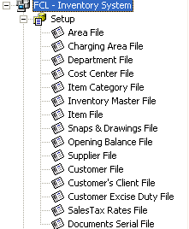 | 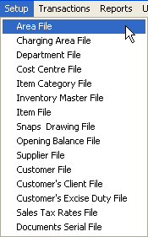

In the subsequent pages, each Setup entry is described briefly with the help of screen-shots.
Area File
_______________________________________________________________________________

Description
A simple Code-Name data entry form for keeping record of different locations where inventory items are moved around or stored as stock.

Note that:
- The names and nature of such locations vary as per the Inventory Module
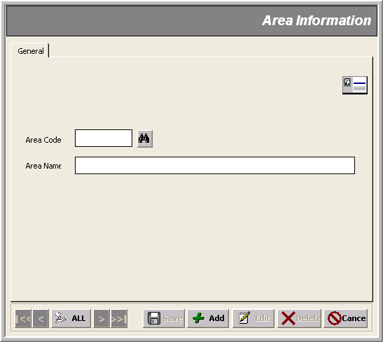
* Area Name (@³⁰)

* Area Code (@@)

Charging Area File
_______________________________________________________________________________

Description
A simple Code-Name data entry form for keeping record of different sub locations in different areas of stock where inventory items are charged. These are cost centers of production departments.

Note that:
- The behavior of Charging Area in Receipt Transactions is as ‘Department’ whereas, in Issue Transactions, it is used as ‘Charging Area’
- This is to categorize items so that they could be grouped in reports by Charging Area.

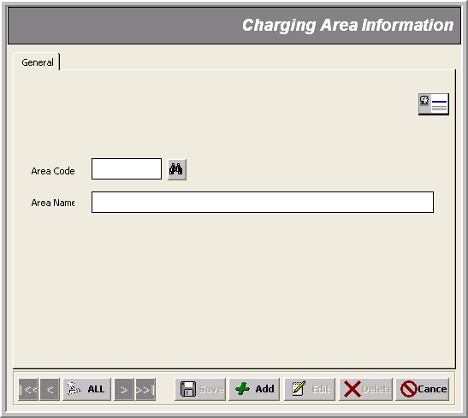
* Charging Area Name (@³⁰) (@³⁰)

* Charging Area Code (@@@@) (@@@@)

Department File
_______________________________________________________________________________

Description
A simple Code-Name data entry form for keeping record of different financial departments of FCL.

Note that:
- This is a sort of parent table of cost centers used in financial module
- This is to categorize items so that they could be grouped in reports by Departments

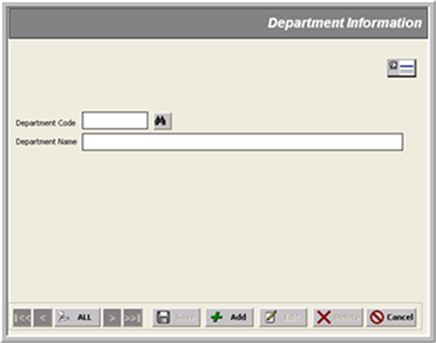
* Department Code (@@)
* Department Name (@³⁰)

Cost Center File
_______________________________________________________________________________

Description
A simple Code-Name data entry form for keeping record of different sections of ‘Production’ or ‘Non-Production’ departments applicable/used in financial module.

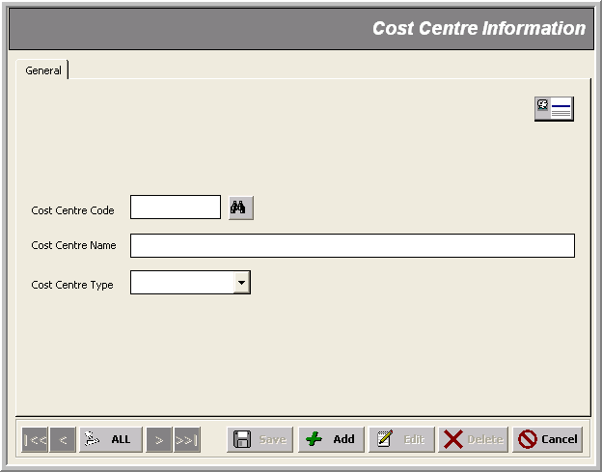
* Cost Center Name (@³⁰)

* Cost Center Code (@@)
* Cost Center Type

Item Category File
_______________________________________________________________________________

Description
This is to categorize Items so that they could be grouped in reports.

Note that:
- This is an integral part of item file

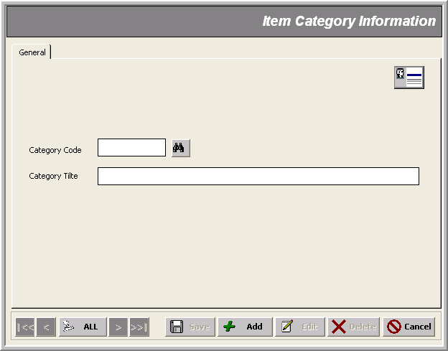
* Category Title (@³⁰)

* Category Code (@@)

Inventory Master File
_______________________________________________________________________________

Description
The heart of the Inventory Modules wherein we specify different GL accounts which would be affected by those items’ transactions which lie under this particular master file.

Note that:
- This is the parent table of Item file
- The account heads to be affected are mentioned in Financial Codes tab as follows:
1- Inventory :
Receipt Account
Issue Account
WIP (Work in Process) Accounts OR Expense (PR & NP) Accounts
COGS (Cost of Goods Sold) Account
2- Government Levis :
Sales Tax Account
Excise Duty Account
3- Revenue :
Sales Account
Process Account
Export Sale
4- Others :
Freight Account
Unpaid Bills Account
Others Account
Note that:
- Inventory Accounts difference among each inventory modules is as follows:
Expense (PR & NP) Accounts IN Retained Stock, Printing & Stationary and Engineering Stores
REPLACES
WIP (Work in Process) Accounts IN Fixed Assets, Finished Goods, Raw Material, Packing Material Stores

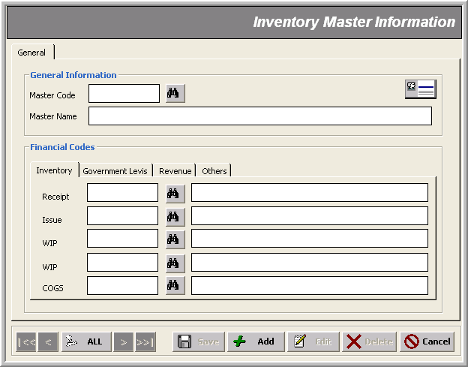
Receipt GL Account

* Master Code (@@)
* Master Name (@³²)
Issue GL Account

WIP GL Account

WIP GL Account

COGS GL Account

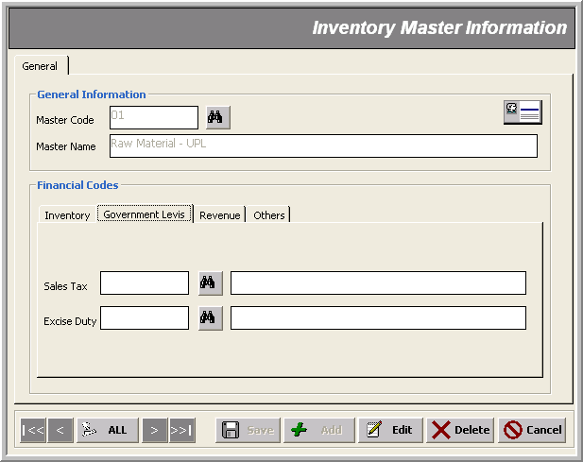
Sales Tax GL Account

Excise Duty GL Account

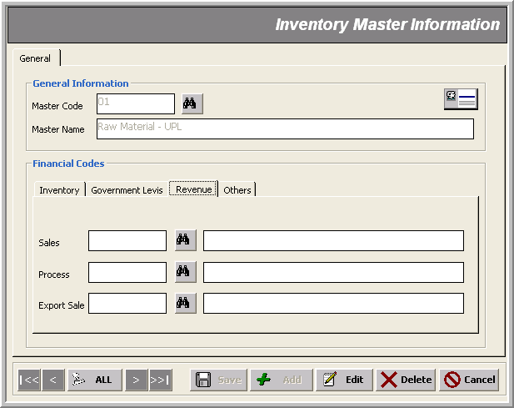
Sales GL Account

Process GL Account

Export Sale GL Account

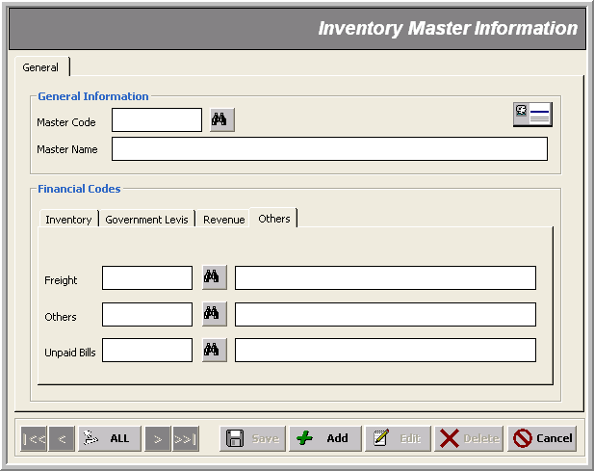
Unpaid Bills GL Account

Freight GL Account

Others GL Account

Item File
_______________________________________________________________________________

Description
This form is used for entering data about different items with the following information.

Note that:
- This is the child table of Inventory Master file
- First 2 digits of an item code show to which master file the items belong
- Only the administrator can turn an item’s status into ‘Un-active’ / ‘Active’ otherwise it is invisible
- General tab has some dynamic fields that change according to the inventory module; this is explained as below; field description marked ‘Same’ means that the corresponding inventory module has the same meaning as mentioned before; while ‘N/A’ means that the field is not active/applicable here

General T a b F i e l d s
 | Finished Goods | Engineering / Retained Stock | Fixed Asset / CP | Others
Item Code | A 6-digit code | A 6-digit code  00 to 89 for Stackable  90 to 99 for Non-Stackable | A 6-digit code | A 6-digit code
Item Name | A short description of 40 characters length | Same | Same | Same
Specification | Item Specs | Same | Same | Same
Spare Part Code | N/A | Supplier’s Spare Part Code Reference | N/A | N/A
Equipment Ref. | N/A | Valid Multiple Equipment Ref | N/A | N/A
Base Item | This is to classify similar items from different suppliers into same group for reporting purposes; default is the same item | N/A | Same
Charging Area | N/A | Area location for charging items | N/A | N/A
Item Category | This is also to categorize items so that they could be grouped in reports | N/A | Same | Same
Sales Tax Type | Claimable  Un-Claimable | Stackable  Non-Stackable | Claimable  Un-Claimable | Only Claimable  (for RM & Packing Stores)  Claimable  Un-Claimable  (for Printing & Stationary Store)
Item Type | Process  (i.e. for which FCL is liable)  Purchase  (i.e. for which FCL does not establish any liability) | Normal | Process  Purchase | Process  Purchase
U/M | Unit of measurement used for the item | Same | Same | Same
Customer Code | Supplier’s reference used for the item | Same | Same | Same
RT3 | Whether or not RT3 tax applies | Same | Same | Same

Specification
* Sales Tax Type
* Base Item
*Item Code (@⁶)
* Item Name (@³²) (@⁴⁰)

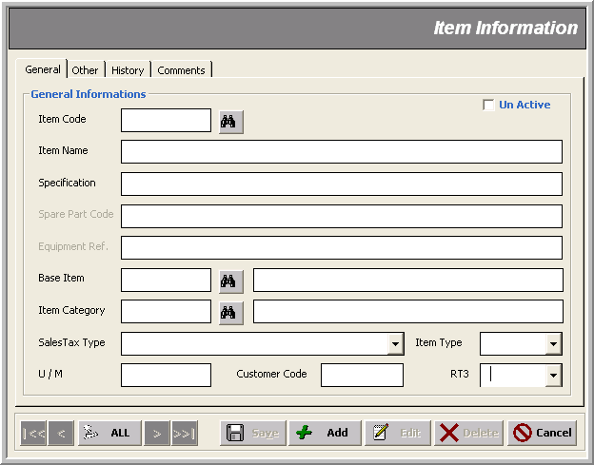
Customer Code (@^{n})
* Unit of Measurement (@^{n})
* Item Type
* RT3 Applies?
* Item Category
Un-Active
Note that:
- Other tab, too, has some dynamic fields that are editable according to the inventory module; this is explained as below

Other T a b F i e l d s
 | Finished Goods | Engineering / Retained Stock | Fixed Asset / CP | Others
Storage Information  Rack No  Bin No | Enabled | Enabled | Enabled | Enabled
Stock Level Information  Re-Order Level  Re-Order Quantity  Critical Level | Disabled | Enabled | Enabled | Enabled
Composition & Allowance  Active %  Wastage % | Disabled | Disabled | Enabled | Enabled
Price & Contents  Standard Cost  Sales  Contains | Enabled | Disabled | Disabled | Disabled
Clearance Rates  Excise  Sales Tax | Enabled | Disabled | Disabled | Disabled

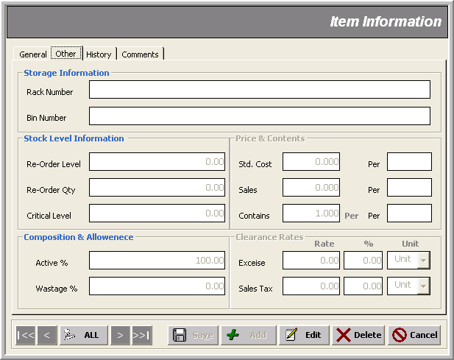
Note that:
- History tab is there to provide us with previous years’ total issues; this remains as is in all inventory modules

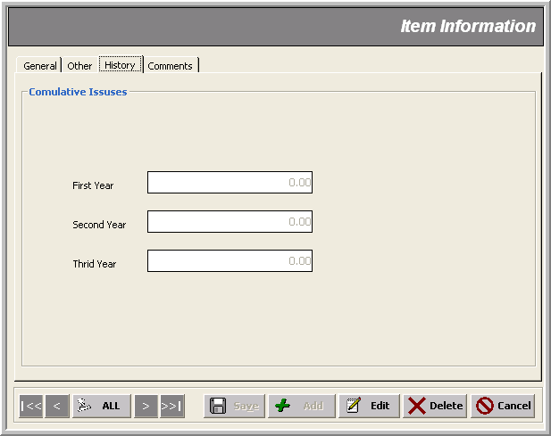
Note that:
- In Comments tab, we can save away our remarks about the item date wise; this remains as is in all inventory modules

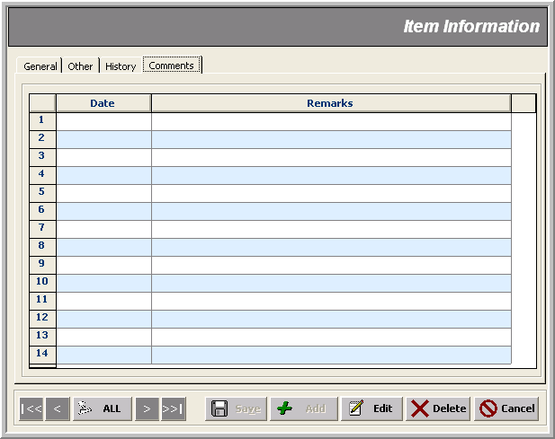
Snaps and Drawings File
_______________________________________________________________________________

Description
This form provides us with snap-shots of items. The snap given in Standards tab gives the specs/recipe details by manufacturer.

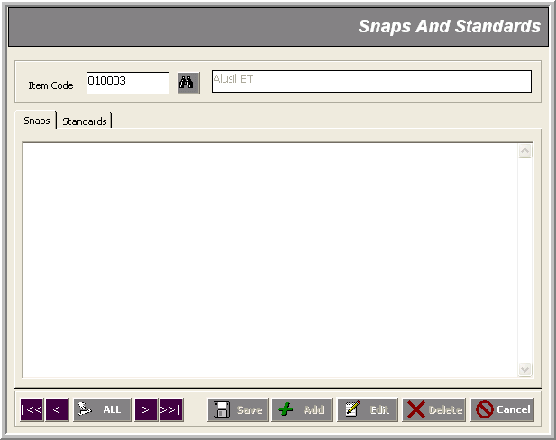
* Item Code
Item Snaps & Standards in any Image Format

Note that:
- Images are inserted by right clicking on the white canvas area provided
- Multiple images are possible to save away in both tabs
- ‘Save/Add/Edit/Delete’ Control-buttons are there only for the actual record not the snaps being inserted/deleted; for these actions you use the menu popped up on the right-click
- All images are stored on the server’s local drives not in the main database
- Standards tab changes into Drawings tab for some stores (e.g. Retained Stock, Engineering) to give us a piece of drawing of the item in image format

Opening Balance File
_______________________________________________________________________________

Description
This form is used for entering opening balances of different items’ quantities in stock with respect to the specified area.

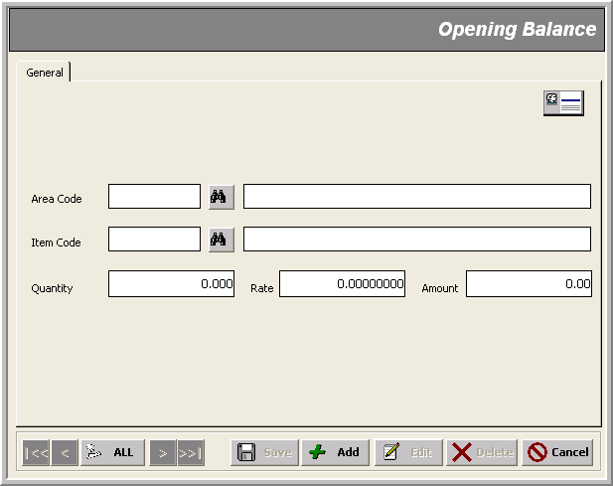
* Area Code
* Item Code
Amount
Rate
Quantity
Supplier File
_______________________________________________________________________________

Description
This form keeps information about suppliers such as name, contacts, income/sales tax Nos., credit days and bank information.

Note that:
- Changes made in Suppliers’ data are reflected in all relevant FCL Modules
(e.g. Production, GL etc)

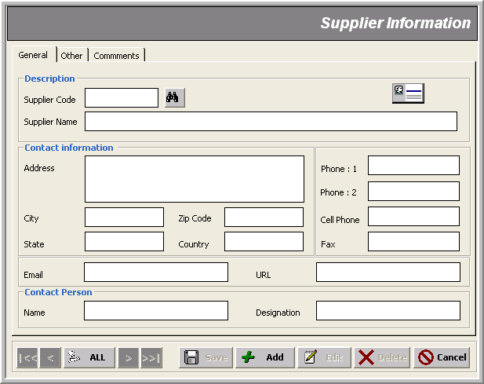
* Supplier Name (@⁴⁰)
Supplier Contacts
* Supplier Code (@⁸)
Supplier Contact Person

Note that:
- In Other tab, we can save other financial information about the supplier such as income tax, sales tax, credit terms and bank information
- Supplier’s Credit Days Limit specified here is used in aging of invoices

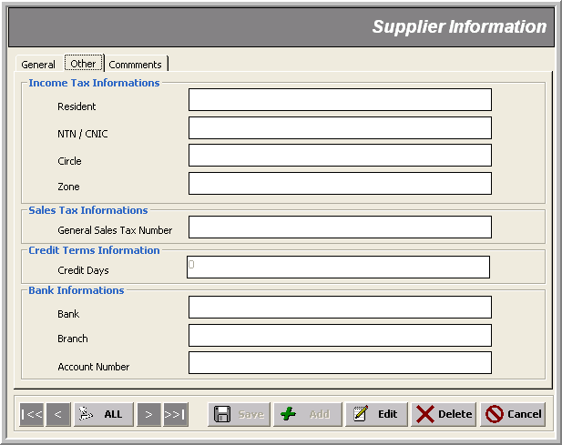
Supplier Credit Days Limit

Note that:
- In Comments tab, we can save away our remarks about the supplier date wise; this remains as is in all inventory modules

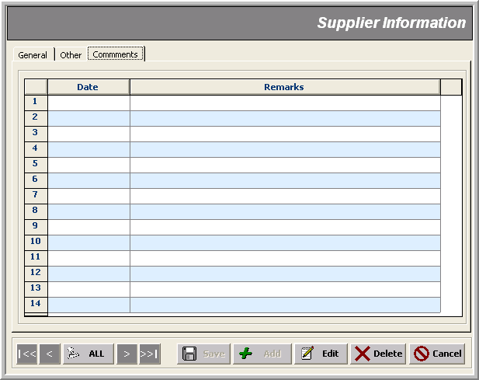

Customer File
_______________________________________________________________________________

Description
This form keeps information about customers such as name, contacts, income/sales tax Nos., credit days and bank information.

Note that:
- Changes made in Customers’ data are reflected in all related FCL Modules
(e.g. Production, GL etc)

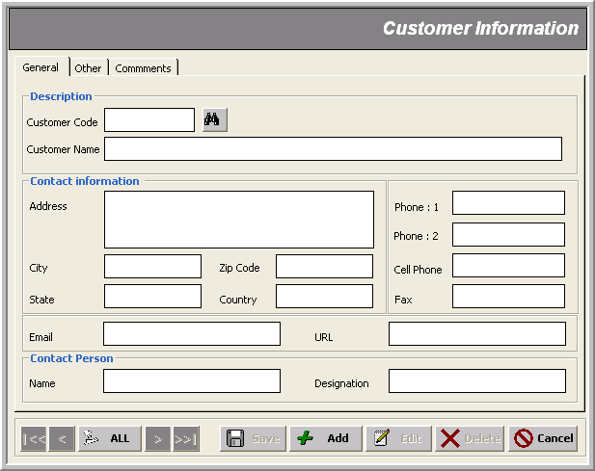
* Customer Code
* Customer Name
Customer Contacts
Customer Contact Person
Note that:
- In Other tab, we can save other financial information about the customer such as income tax, sales tax, credit terms and bank information
- Customer’s Credit Days Limit specified here is used in aging of invoices

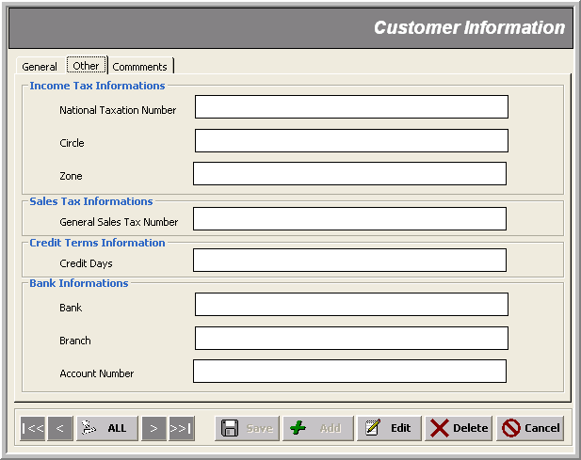
Note that:
- In Comments tab, we can save away our remarks about the customer date wise; this remains as is in all inventory modules

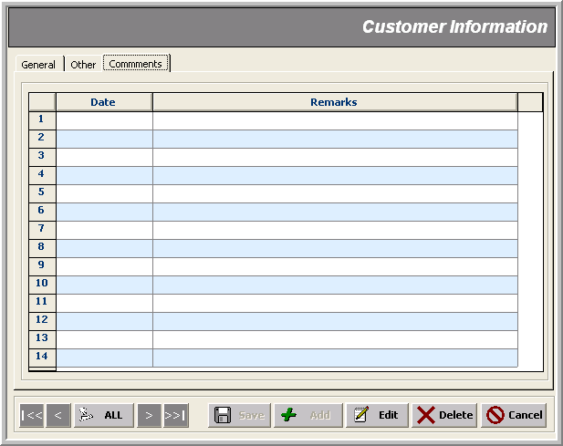
Customer’s Client File
_______________________________________________________________________________

Description
This form keeps information about customers’ clients such as name, contacts, income/sales tax Nos. and credit days.

Note that:
- A customer’s client is considered as an FCL customer
- A customer’s client could also be a warehouse as flagged with status: Warehouse.

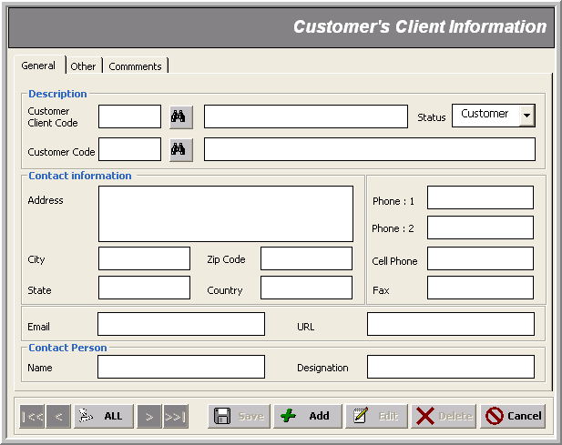
* Customer Client Code
* Customer Code
Status
* Customer’s Client Contacts
* Customer’s Client Contact Person
Note that:
- In Other tab, we have only two kinds of financial information about the customer-client customers such as income tax and sales tax information

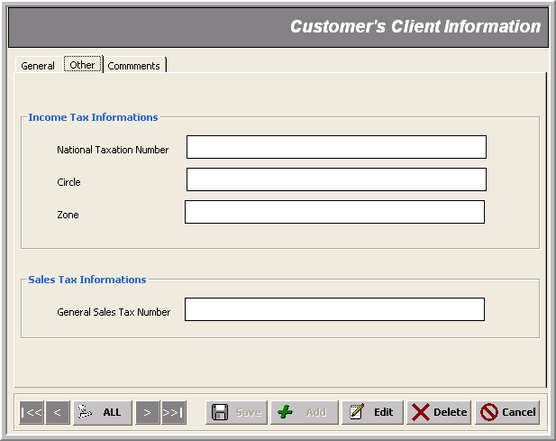
Note that:
- In Comments tab, we maintain our remarks about the customer’s clients date wise; this remains as is in all inventory modules

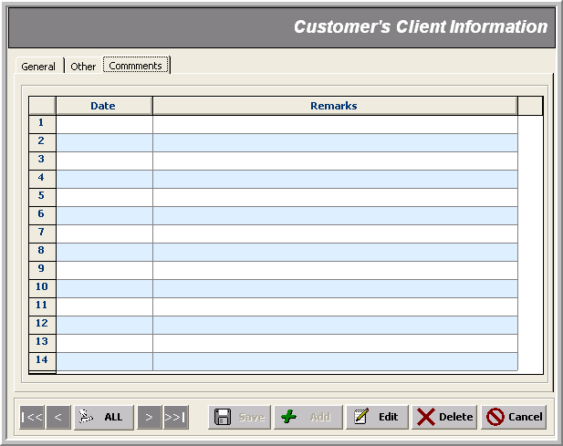
Customer Excise Duty File
_______________________________________________________________________________

Description
If customers want FCL to maintain their Excise Duty on retail selling price, this is accomplished here.

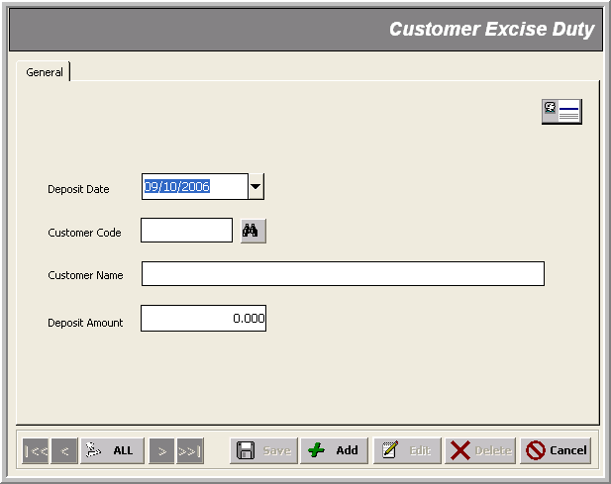
* Customer Code
* Customer’s Deposit Date
Customer Deposit Amount
Sales Tax Rate File
_______________________________________________________________________________

Description
This form is used to define items’ sales tax on monthly basis.

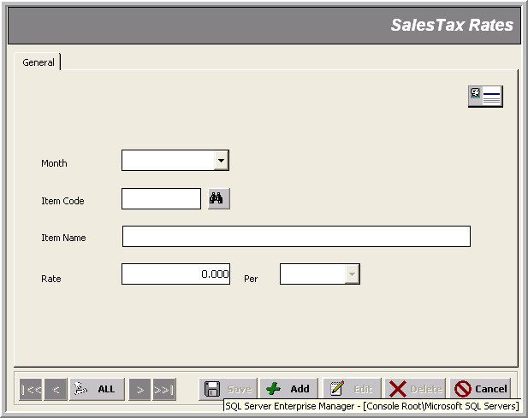
* Effective Month
* Item Code
Rate
Document Serial File
_______________________________________________________________________________

Description
This form is used to specify serial numbers for all kinds of transactions; the general format is ‘yymmnnnn’ where:
‘yy’ => current year
‘mm’ => current month
‘nnnn’ => actual serial showing no of transactions of this type
Note that:
- For Finished Goods store, transactions of type ‘Issue’ are not maintained on year-month basis, so a continuous serial is used for the whole year.
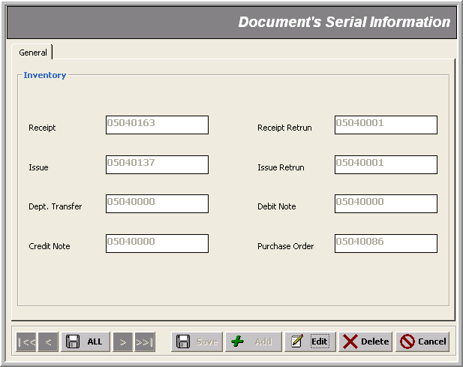
Transactions
_______________________________________________________________________________

There are ten transactions in the inventory modules that can be classified into the following categories:

- Ordering Suppliers for Goods – Purchase Order
- Receiving / Returning Goods Purchased from Suppliers – Receipt & Receipt Return
- Recording Transfer of Items from one Area to another – Departmental Transfer
- Issuance / Returning Goods Issued to Charging Areas or Customers – Issue & Issue Return
- Recording Purchase of Services – Services Purchase
- Adjusting Goods Purchased – Debit & Credit Notes
- Drawing Vouchers - Purchase/Sale Vouchers

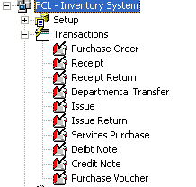 | 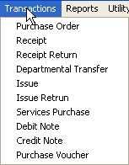

In the next sections, you will learn every transaction one by one, with the following aspects keeping in view:

- Mandatory fields info
- Optional fields info
- General Restrictions
- Difference of behavior with respect to individual inventory module
- User Specific Constraints
Note that:
- fields marked with asterisk * in the snap-shots are mandatory
- transaction number gets generated automatically in ‘yymmnnnn’ format where:
yy => current year
mm=> current month
nnnn=> Auto generated serial no.
- transaction dates must lie within the same month as indicated by the transaction number; or else you get an error message:
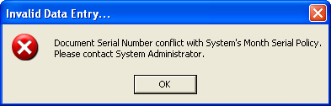
or
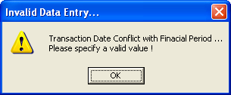
- But for Finished Goods Store, a continuous serial no. is generated for the whole year Issue transactions
- While selecting items, you can over-write their previous specs
- ‘Un-Active’ items don’t appear in the selection combos
- A transaction gets LOCKED as soon it is created and can be editable only when Un-Posting Process is run by the authorized user (e.g. the administrator )
- If the Posting Process has locked a date, transaction entry is disallowed thereon:
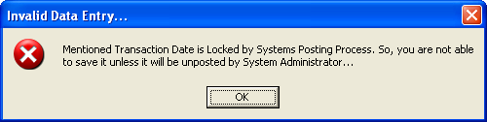
- Similarly, there is some particular item information which is not visible and hence un-editable for the normal users; such as:
- GL Accounts
- Sales Tax Rates
- Item Delivery Status
- No transaction is allowed if there is already some un-posted transactions:
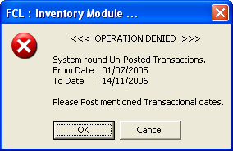
- Similarly, if Posting or Auditing process is currently in progress; the system denies any transaction entry with an alert like:
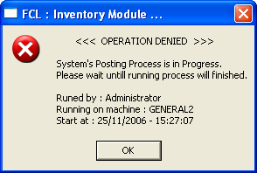

Purchase Order _______________________________________________________________________________
Use case: Ordering Suppliers for Goods

Description
This form is used to create Purchase Orders with the following mandatory data entry:

- PO Number (Auto generated in ‘yymmnnnn’ format)
- PO Date
- PO Type
(determined by the inventory module: Supplies for stockable, Services for non-stockable inventory)
- Department
- Supplier
- Prepared By
- More than one items (filtered as per the inventory system and PO Type)

Optional information includes:
- Request No, with Date
- Quotation No, with Date
- Delivery At, with Date
- Nature
- Terms & Condition
- Remarks

Note that:
- While selecting items, you can over-write their previous specs
- For items with Sales Tax Type specified as ‘non-claimable’, price or rate is input including Sales Tax amount (i.e. rate=price + sales tax)
- Normal users can only view item details up to Amount column; the administrator has some more special fields visible; for example he/she can edit items information
such as :
- S/T % (used to calculate sales tax amount)
- Status (Pending when item’s delivery is incomplete; Closed when it has been received completely OR the administrator wants to ‘cancel’ the transaction )
- Filled Value is the quantity whose receiving has been recorded
- ‘Un-Active’ items don’t appear in the selection combos
- In Finished Goods Store , a Purchase Order is not applicable

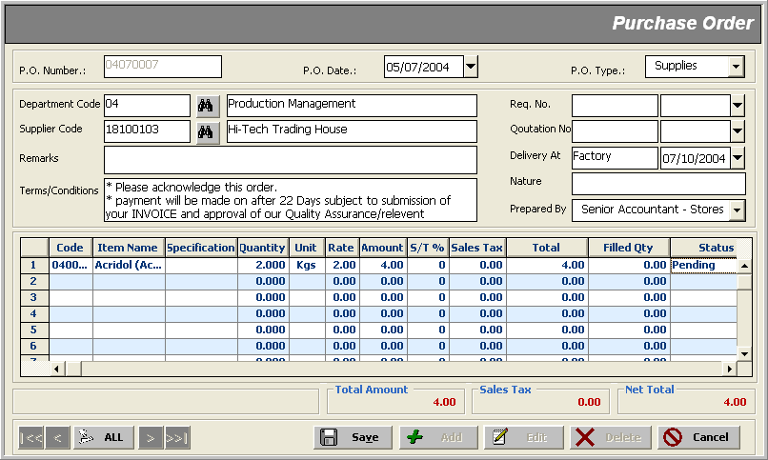
* Prepared by
* Transaction Type
* Item
* Item Quantity
* Transaction Date
* Department Code
* Supplier Code
Sales Tax Rate

Receipt & Receipt Return _______________________________________________________________________________
Use case: Receiving / Returning Goods Purchased from Suppliers

Description
These forms are used to record receipts and return of items from/to suppliers against a Purchase Order , with the following mandatory data entry:

- Transaction Number (Auto generated in ‘yymmnnnn’ format)
- Transaction Date
- Transaction Nature (or Shift Status for Finished Goods Store )
(determined by the inventory module; Local or Import; to be used in excise duty calculation)
- Area
- Supplier (or Department for Finished Goods Store )
- More than one items (filtered as per the inventory system) with PO No (optionally) and Quantity information

Optional information includes:
- D.C. No with Date (absent in Finished Goods Store )
- Client PO No with Date (absent in Finished Goods Store )
- GRIR No with Date (or PRD No for Finished Goods Store )
- Remarks

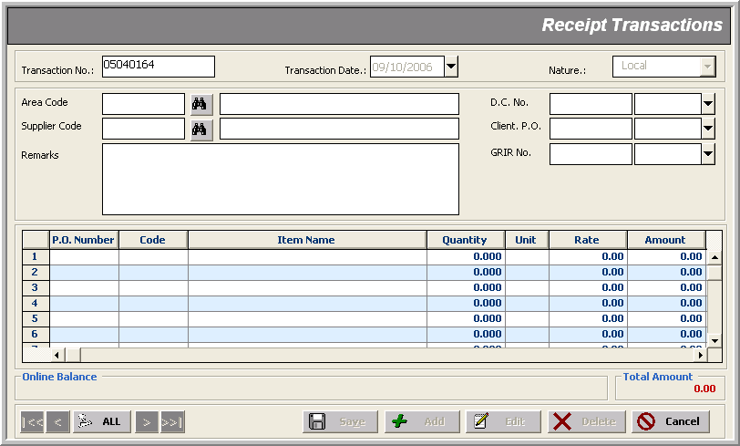
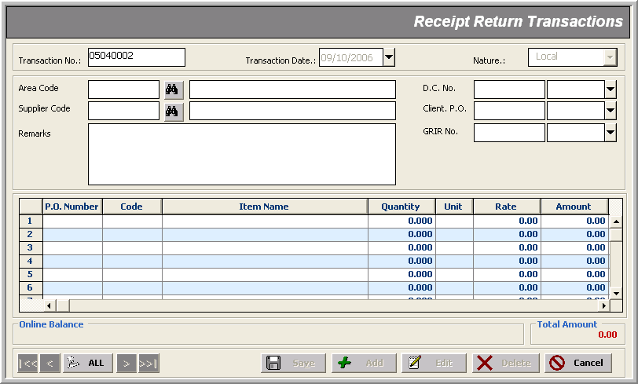

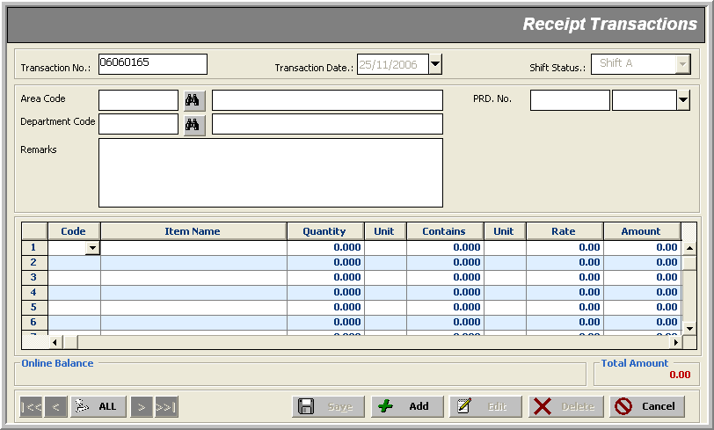
For Finished Goods Store

Note that:

- Receipts are made based on the selected items which can or cannot associate some Purchase Order with them
- A receipt transaction gets LOCKED as soon it is created and can be editable only when Un-Posting Process is run by the authorized user (e.g. the administrator )
- No receipt is allowed if there is already some ‘un-posted’ transactions
- Just like in Purchase Order , normal users can only view item details up to Amount column; the administrator has some more special fields visible; for example he/she can edit item information such as :
- Debit GL Account
- Credit GL Account
- For non-stockable items a Services Purchase transaction is made rather than recording a receipt
- You can’t Return a quantity more than receipt quantity; otherwise this message box alerts you:
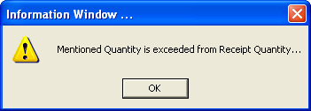
- Similarly, a Receipt Return transaction does make sure that you are not returning more than the current ‘Online Balance’ quantity; if so, you are warned:
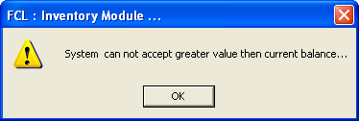

- For Finished Goods Store, these data entry forms vary from those of other modules in that here we have a Charging Area Department from where to receive the goods rather than a Supplier; also, no Purchase Order number and no item rate are needed by the same reason

- In Finished Goods Store, Shift Status flag indicates in which shift the receipt of item(s) took place

Departmental Transfer _______________________________________________________________________________
Use Case: Moving Items from one Area to Another

Description
This form is used to record movement of items from one department to another, with the following mandatory data entry:

- Transaction Number (Auto generated in ‘yymmnnnn’ format)
- Transaction Date
- From Area
- To Area
- More than one items with specified Quantity

Optional information includes:
- GRIR No (or PRD Reference for Finished Goods Store)
- Remarks

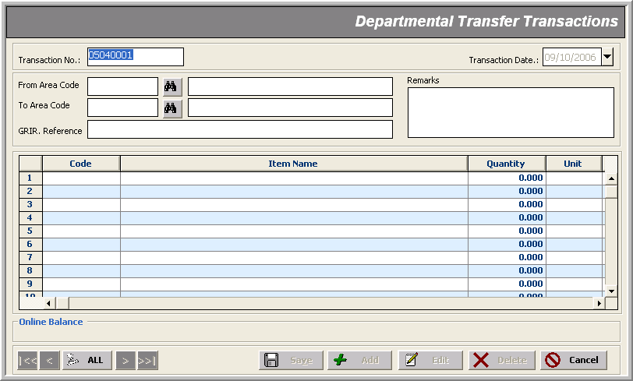

Note that:
- Obviously, both From and To Area can’t be the same:
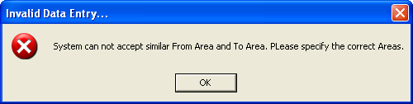

Issue & Issue Return _______________________________________________________________________________
Use Case: Recording Issuance / Returning of Goods Issued

Description
This form is used to record issuance of items (or returning of issued items) to different charging areas (or to Customers’ clients, in case of Finished Goods Store), with the following mandatory data entry:

- Transaction Number (Auto generated in ‘yymmnnnn’ format)
- Transaction Date
- Area
- Cost Centre or Customer (Customer for Finished Goods Store)
- Charging Area or Client (Client for Finished Goods Store)
- Nature (or AR Type for Finished Goods Store)
- Category (for Finished Goods Store)
- (Credit/Cash) Days (for Finished Goods Store)
- More than one item with specified Quantity

Optional information includes:
- MIR No with Date (absent in Finished Goods Store)
- Remarks
- Plan No, DA No, Billty No (for Finished Goods Store)

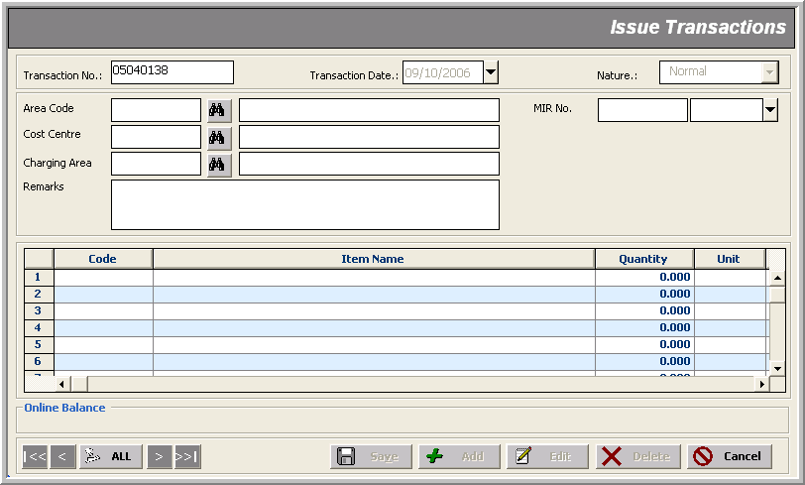

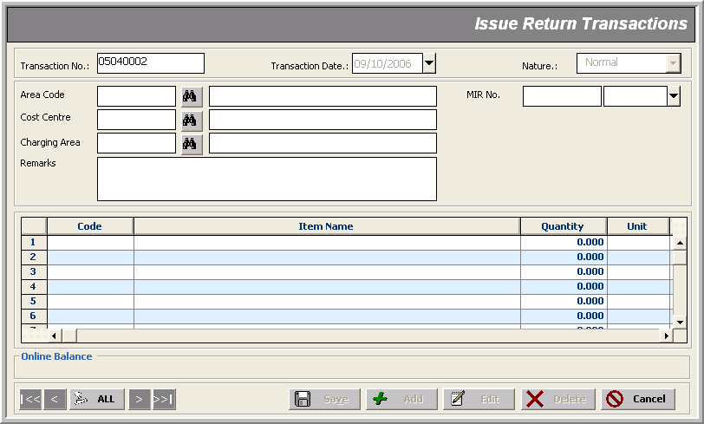
For Finished Goods Store

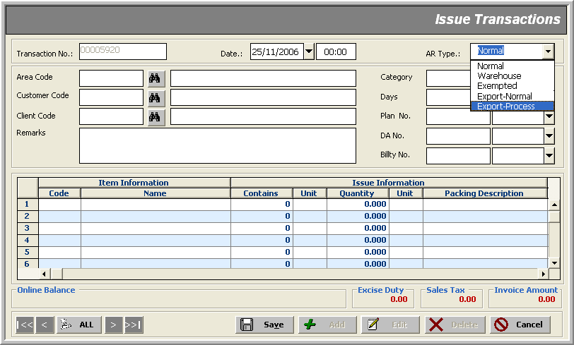

Note that:
- Issue/Issue Return transactions are categorized into two types:
- those involving FCL’s internal movement of items to different Charging Areas
- those involving FCL’s customers (only applicable for Finished Goods Store)
- No Purchase Order is needed in Issue/Issue Return transactions
- For Finished Goods Store, these data entry forms vary drastically from those of other modules in that here we are ‘ issuing items to the Customers/Clients ’ rather than ‘ to our own Charging Areas ’; hence the bunch of additional header information; namely:
- Category helps achieve grouping in reports; see Glossary for the meaning of given options
- (Credit/Cash) Days
- Plan No & Date
- DA No & Date
- Billty No & Date
- AR Type flags which strategy is to be used to calculate Customer’s Excise Duty; see Glossary for the meaning of given options
- There is an ‘Excise Duty-relation’ between AR Type and Category selections which,
on violating, raises an objection of the form:
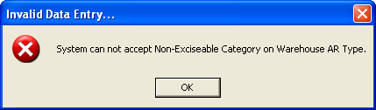
- Items are filtered based on AR Type and Category selections; which could be changed after accepting a polite indication:
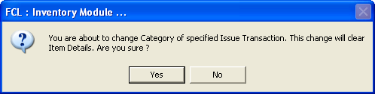
- Again there are fields in the items’ details which are only visible / editable to the authorized user

Services Purchase _______________________________________________________________________________
Use Case: Recording Purchase of Services

Description
This transaction is only applicable for non-stockable items relating to Engineering Store. This is possible with or without a Purchase Order of type ‘Services’ or ‘Contract’ given the following mandatory data entry:

- Transaction Number (Auto generated in ‘yymmnnnn’ format)
- Transaction Date
- Transaction Nature (see Glossary for the meaning of given options)
- Supplier
- Charging Area
- Cost Center
- More than one items (only non-stockable filtered automatically) with PO No (optionally) and Quantity information

Optional information includes:
- Req. No with Date
- Remarks

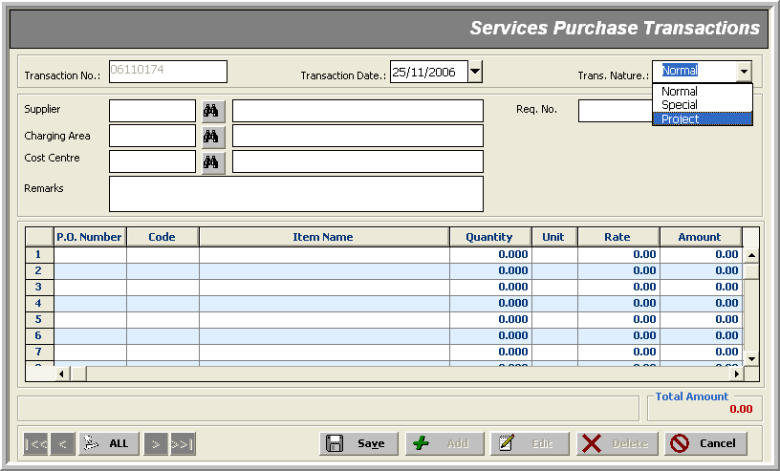

Note that:
- Again there are fields in the items’ details which are only visible / editable to the authorized user

Debit /Credit Notes _______________________________________________________________________________
USE Case: Adjusting Purchase or Sale

Description
These forms are used to record adjustment of items’ purchase (or sale in case of Finished Goods Store), with the following mandatory data entry:

- Transaction Number (Auto generated in ‘yymmnnnn’ format)
- Transaction Date
- Supplier (or Customer in Finished Goods Store)
- Financial Code (Affected GL Acc)
- Cost Center
- More than one items with specified Quantity

Optional information includes:
- DC No (or DC Ref in Finished Goods Store)
- PO No (absent in Finished Goods Store)
- GRIR No (absent in Finished Goods Store)
- S/T Inv No with Date (absent in Finished Goods Store)
- Bill No with Date (absent in Finished Goods Store)
- Remarks (absent in Finished Goods Store)

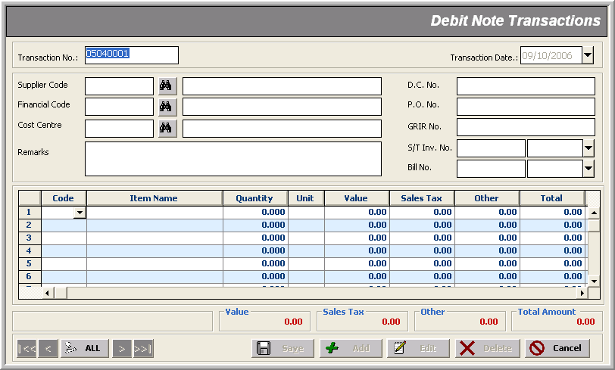

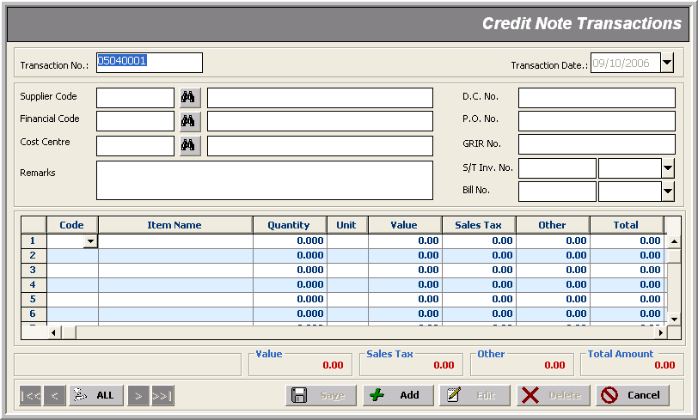

Note that:
- In all inventory modules other than Finished Goods Store, Debit Note and Credit Note are documents issued on behalf of the Suppliers after purchase of item(s) has been ‘regularized’ via a Purchase Order (optionally) and can’t be cancelled out; in such cases, we issue these notes to update the relevant financial accounts; for example:
Scenario :
<< We made a transaction of worth Rs. 100 with a supplier ABC; the purchase got ‘regularized’ and a receipt transaction was recorded affecting our GL Accounts; later the supplier demanded more amount (Say Rs. 115) than the actual deal due to any reason (e.g. increase in rates, delivery charges, etc); in this case, if we are still willing to keep up with this deal, we issue a Debit Note to record this expense rather than cancel the previous receipt transaction and start a new one worth Rs. 115 from scratch; similarly, in case of decrease in amount payable for any reason (e.g. damaged or unacceptable supplies), a Credit Note is issued on behalf of that supplier>>
- In Finished Goods Store, the same situation applies on our customers; the difference is that here we are the suppliers and these documents ‘are truly’ Debit Notes or Credit Notes with respect to our GL
- Debit Notes or Credit Notes generate vouchers as per their nature automatically

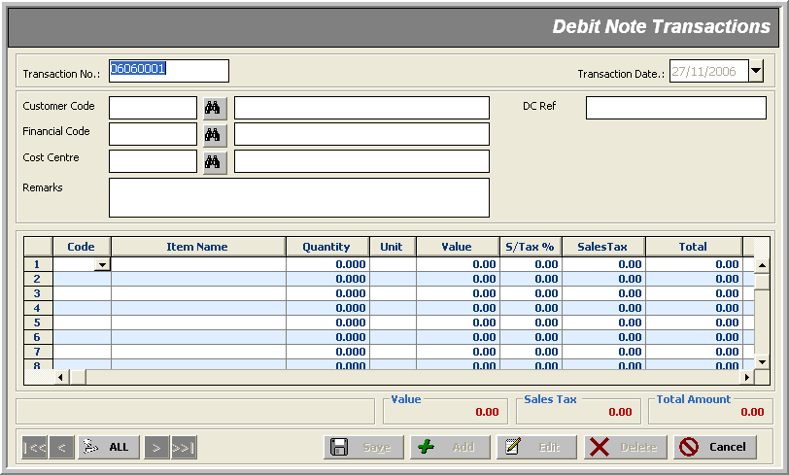
For Finished Goods Store

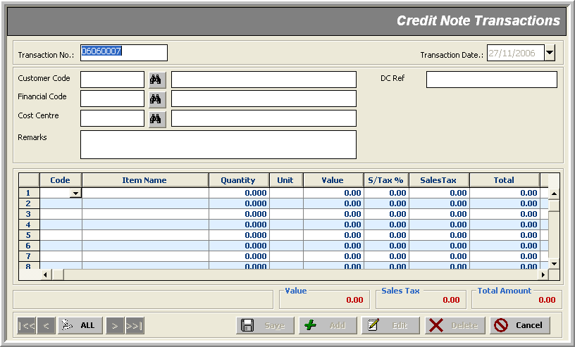
For Finished Goods Store

Purchase Voucher _______________________________________________________________________________
USE CASE: Creating Bills against Purchase or Sale Orders

Rate
Rate
Customer

Description
These forms are used to issue bills against items’ Receipt or Receipt Return transactions, with the following mandatory data entry:

- Transaction Number (Auto generated in ‘yymmnnnn’ format)
- Transaction Type (Receipt or Return)
- Transaction Date
- Supplier
- More than one items with specified Quantity

Optional information includes:
- Bill No
- S/T Inv No
- Billty No
- Days
- Remarks
- SRN No
- P.O. No

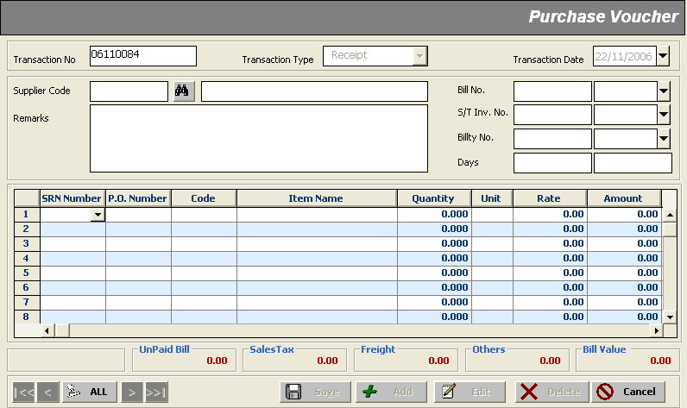

Note that:
- In Finished Goods Store, Purchase Vouchers are not applicable; instead, the corresponding Sale Vouchers automatically generate against each Receipt or Receipt Return transaction

Reports
_______________________________________________________________________________

The Inventory module reports can be divided in three categories:

- Setup Reports
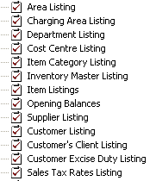
- Transaction Activities Reports
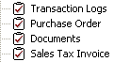
- Financial Statement Reports
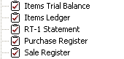
- UPL Reports
- Utility Reports

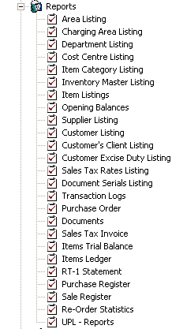 | 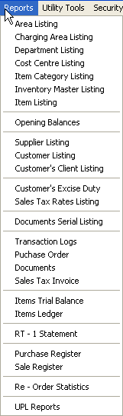

Utility Tools
_______________________________________________________________________________

Utility Tools cover periodic processes within a closing schedule life-cycle, such as:

- Auditing
- Posting Transactions
- Modifying Standard Rate
- Applying Standard Rate
- Data Validation

A couple of processes belong to only Finished Goods Store; viz.:

- Sales Tax Rates Processing
- Utility Bills Payment

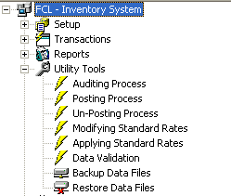 | 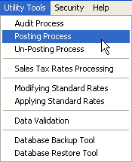

Auditing Process _______________________________________________________________________________

Description
Auditing Process is performed to trace out buggy transaction activities. It performs the following tasks:

- Updates ‘online balances’ of items in all areas
- Updates Purchase Order ‘filled quantity’ with ‘SRN received quantity’
- Checks through all the transaction life cycles and updates the status as ‘lock’ or ‘unlock’
- Updates Purchase Voucher (or Sale Invoice in case of Finished Goods Store) Quantity and the related transaction (Receipt/Receipt Return/Dr Note/Cr Note) Quantity

Here’s how it proceeds:

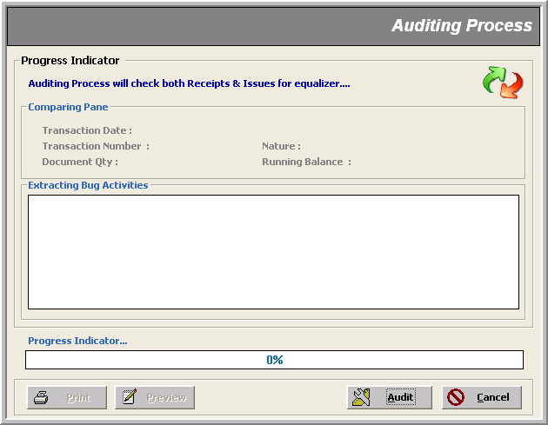
When is clicked, the following window appears indicating the start of Auditing Process.

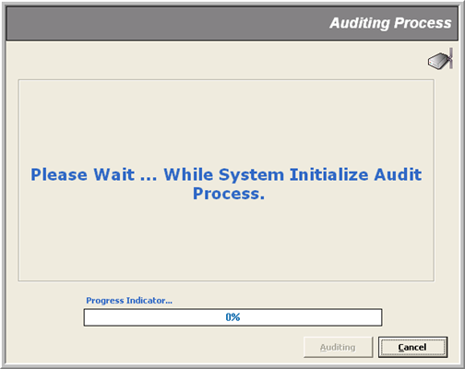

Next window shows that the Auditing Process is checking through transaction activities for possible bugs.
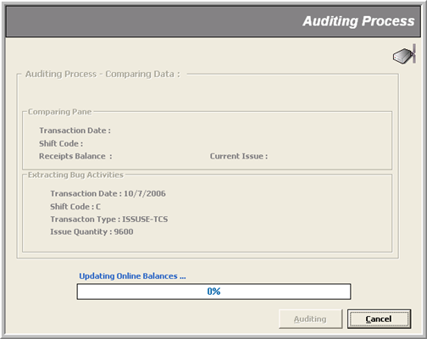
On successful check, a message box pops up saying ‘System did not found any Exception’.

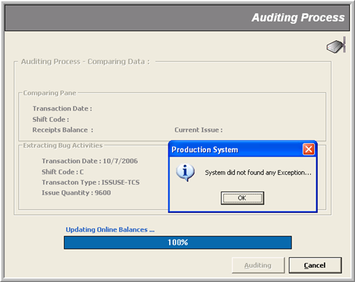s
Posting Process _______________________________________________________________________________

Description
Posting Process is performed to Post transactions in non-editable mode to tag them as ‘confirmed’ transactions. It performs the following tasks:

- Runs the ‘Auditing’ process up to date
- Calculates ‘Average Cost’ of items scanning through all the ‘posted’ transactions per day within the specified date range
- Apply these average rates on:
1) Departmental Transfer
2) Issue
3) Issue Return
- Locks all items in a particular transaction that have been delivered in some quantity

Here’s how it proceeds:
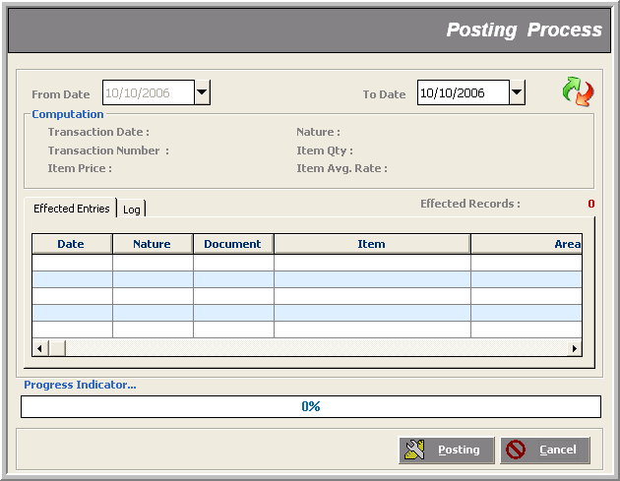

As Posting Process involves Auditing Process, so the system shows up the same screens as in the previous section; later, it initializes the Posting Process; and on finding un-posted data, a message box pops up asking for confirmation to go on.
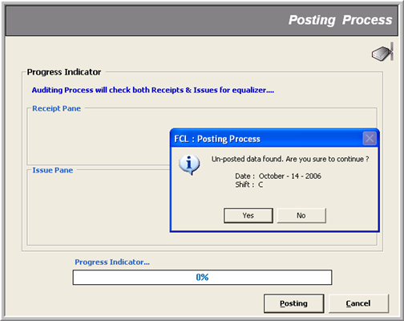

Next window shows the scan progress for un-posted transactions.
Finally, a message box flags the end of process.
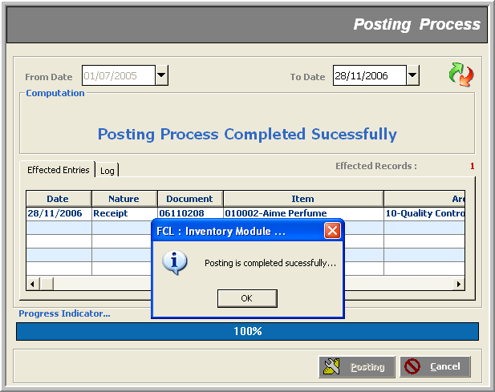

Un-Posting Process _______________________________________________________________________________

Description
Un-Posting Process performs the following jobs:

- Sets ‘Average Cost’ of items to be zero
- If some transaction types are checked AND their respective document no.’s range is provided; it ‘unlocks’ those documents for editing; other wise only first task is done

Note that:
- In Un-Posting Process, ’To Date’ is disabled meaning that the process ‘Un-Posts’ only those transactions that were recorded from ‘From Date’ until NOW
- This impacts the relevant reports in that now you can view only those transaction records that were made until the ‘From Date’ specified (all those ‘Posted’ to date)

Here’s how it proceeds:
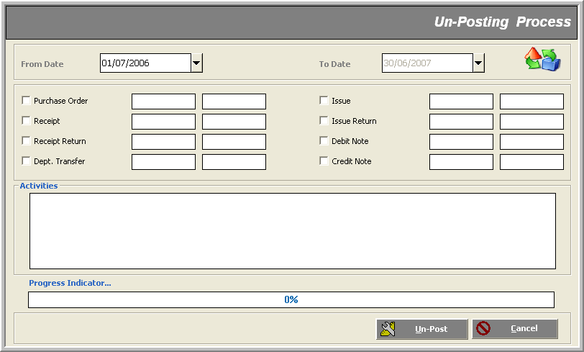

The process signals its successful finish giving a short description of the ‘Activities’ in the text area. If we had given document numbers’ range of a selected transaction nature, the process would have ‘unlocked’ those documents for editing.
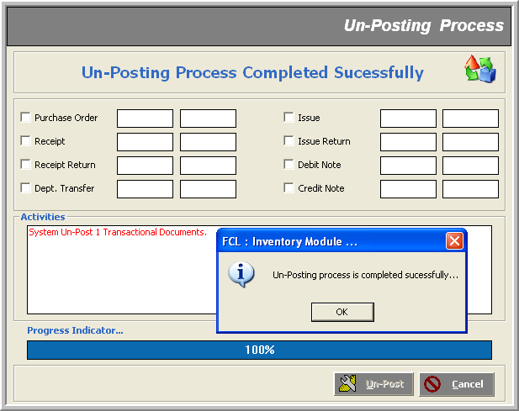

Modifying Standard Rate _______________________________________________________________________________

Description
From here we modify standard rates of different items; which would come into play from the specified effective date.

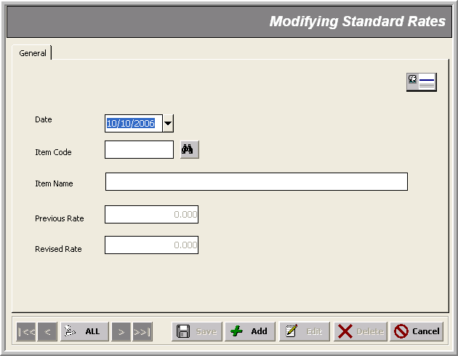
Applying Standard Rate _______________________________________________________________________________

Description
The rates defined in ’Modifying Standard Rate’ are ‘applied’ here as shown by the screen-shot given below:
- on the respective ‘item master’
- on all the transactions lying ‘un-posted’ AND those that are to be made anew

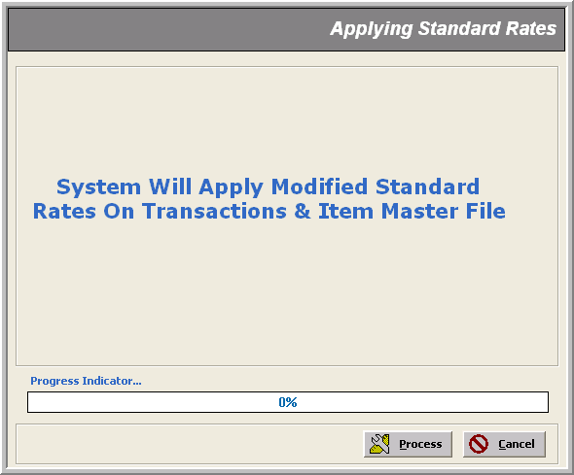
Utility Bills Payments (only in FG) _______________________________________________________________________________

Description
This tool generates payment vouchers for the specified supplier with the given amounts. This process is run every month exclusively for ‘Utility Bills’ to pass them on to the respective expense GL account.

Note that:
- This tools exists in Finished Goods Store only

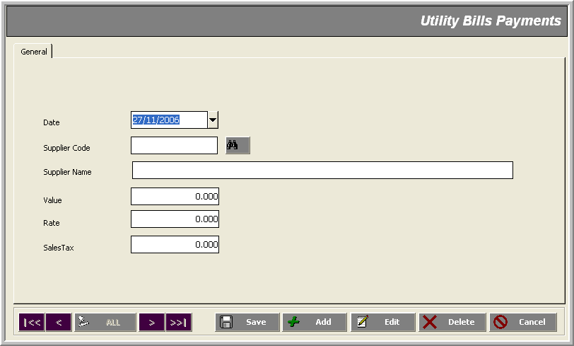

Data Validation _______________________________________________________________________________

Description
This tool performs data validation checks on the specified system. Such as
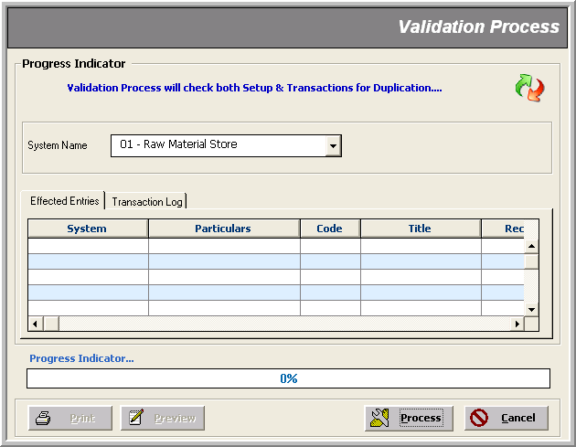

Sales Tax Process (only in FG) _______________________________________________________________________________

Description
This tool applies ‘Sales Tax’ on all the transactions lying in the specified mode and month.

Note that:
- This tools exists in Finished Goods Store only

